**Hawayety**

**An Innovative E-Government Solution for Digitalizing Citizen Identities**

**ABSTRACT IDEA**

Titles:

1 Introduction

Detailed information for each paragraph

1.1)header Hawayety represents a groundbreaking step towards the digitalization of citizen identities in Egypt. By leveraging facial recognition or fingerprint scanning technologies, the application aims to streamline identity verification processes for law enforcement, government officials, and emergency responders. The transition from physical to digital IDs will enhance efficiency, reduce identity-related crimes, and contribute to a more secure and responsive governance system. Hawayety is an advanced e-government application designed for citizens, police officers, government workers, and ambulance personnel in Egypt. The primary goal is to eliminate the reliance on physical identification cards and papers by introducing a secure and efficient digital system. This initiative starts with integrating the Egyptian identification number card and driving license into the system, along with three emergency contacts for added safety. Over time, the application aims to expand its database to include birth certificates, death certificates, car licenses, and other essential government documents. The data gathering process involves periodic updates during the renewal of traditional identification documents.

1.2 System Description inside intro

App input header

1. **Facial Recognition or Fingerprint Scanning:** The application employs state-of-the-art biometric technologies to accurately identify individuals, eliminating the need for physical identification cards.



Documents blockchain data

1. **Integrated Government Documents:** Initially starting with national 1.1)id , 1.2)birth Certificate and driving licenses, and other government-issued documents.( ex p)

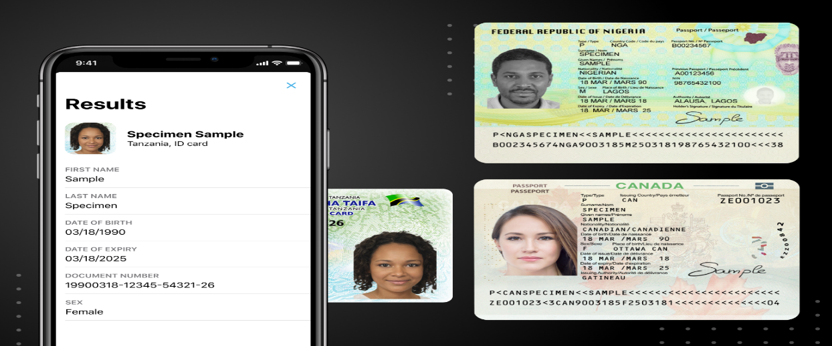

1.3)

3. **Emergency Contact Information:** Users are required to provide three emergency contacts, enabling swift communication in case of accidents, immediate identification. medical emergencies, or ensuring prompt notification to concerned family members in critical situations. where the individual is found unconscious or deceased.

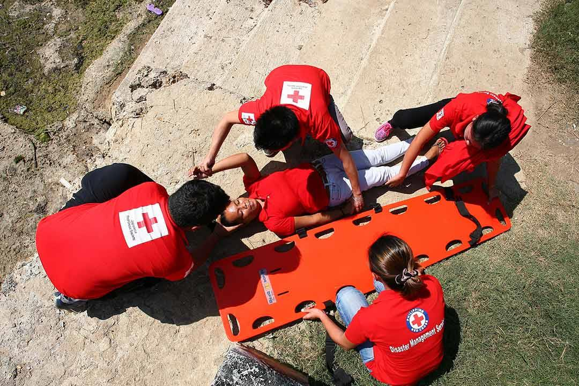

Technologies java ,spring, solidity,web application

4. **Blockchain Technology:** The application utilizes blockchain for secure data storage and retrieval. Blockchain ensures tamper-proof records, enhances transparency, and strengthens the overall security of the system , a revolutionary initiative leveraging blockchain technology as the bedrock for decentralized data storage.



5. **Roles:**

**description**

* Different types of Police Officers
* Ambulance Man
* Civil affairs employee
* Software Engineer
* Traffic Department employee

The implementation of Hawayety follows a phased approach, commencing with the mandatory renewal of physical IDs and driving licenses. During this renewal process, individuals will be required to update their information and provide biometric data. Over a ten-year period, the entire citizen population is expected to be registered on the Hawayety system.

Retrieving associated digital IDs and related information for recognized individuals, leveraging the uniqueness of fingerprints to ensure a higher level of security. The distinctiveness of fingerprints adds an additional layer of confidence as no two individuals share the same fingerprint pattern

***2.background***

***2.1Blockchain:***

A blockchain is a distributed database that maintains a continuously growing list of records, called blocks, chained together using cryptography.

**2.2Benefits :**

**a-Decentralization**

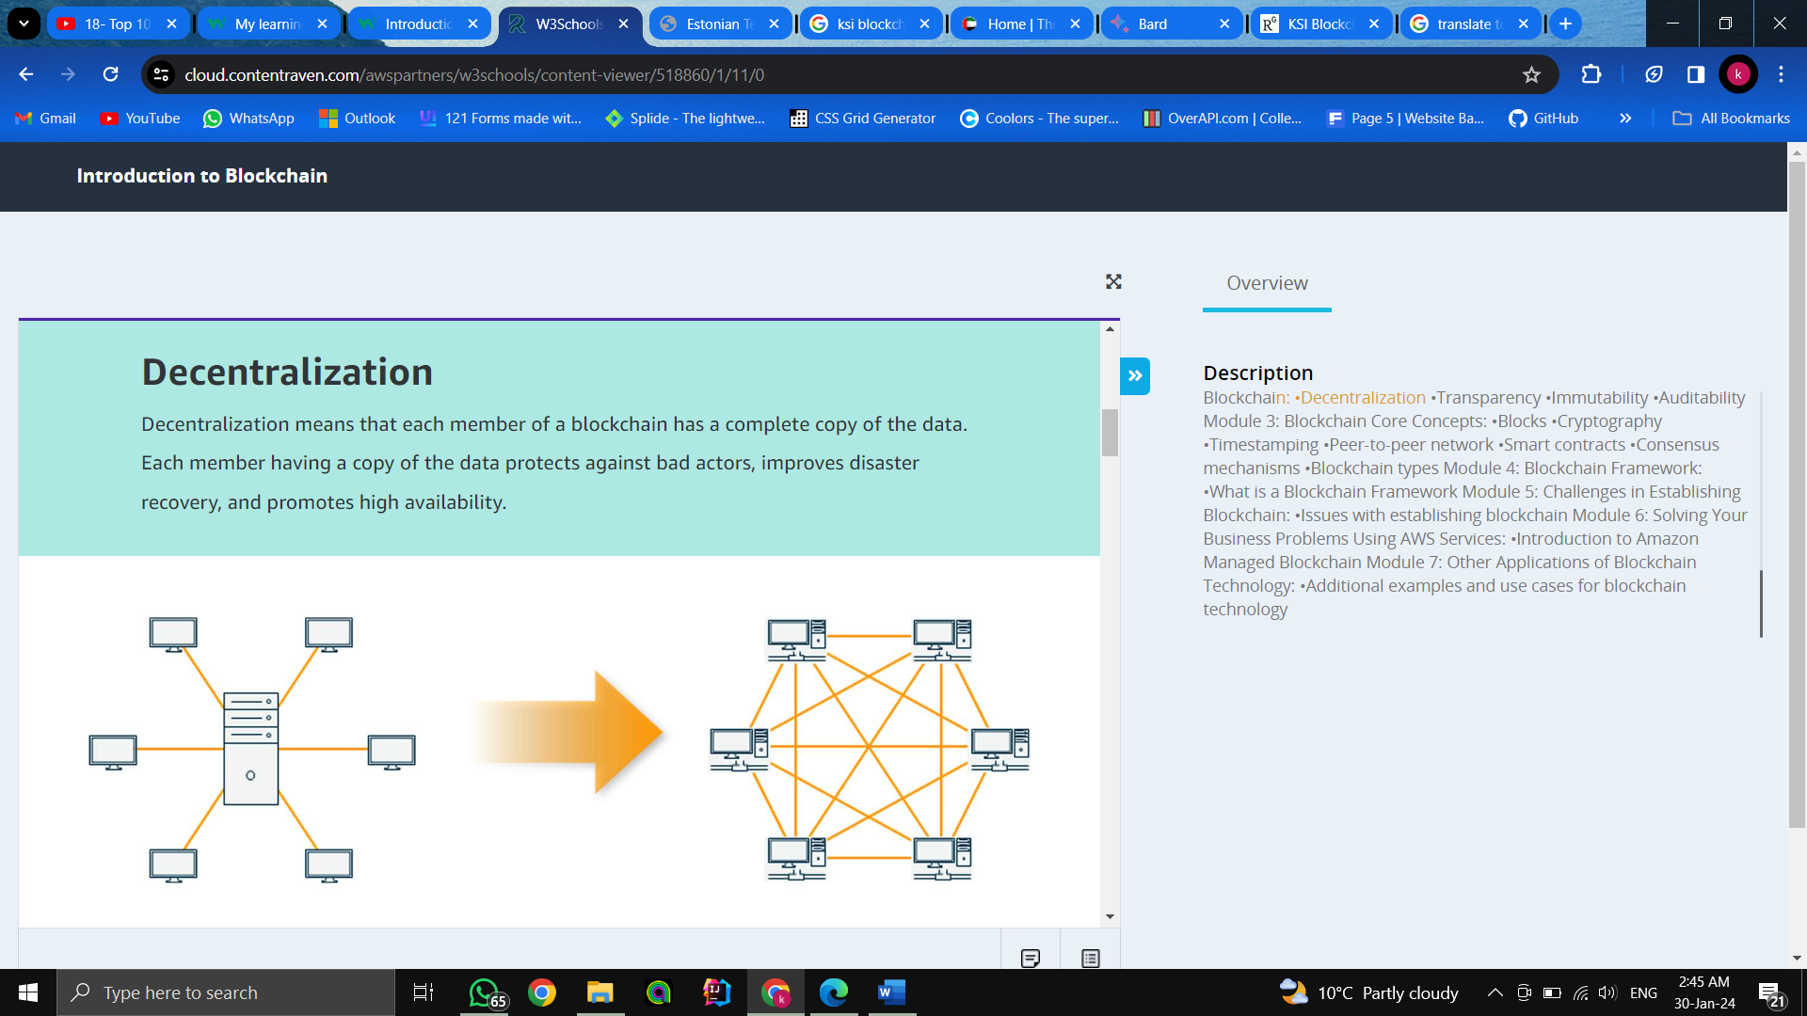

**b-Transparency**

Simply means that the information stored in the blockchain is visible to the members of the blockchain.

**3-Immutability**

Simply means something cannot be edited or changed. You can update the information in a blockchain by adding data, which will be added in a new block.

***3.0)Motivation:***

***Change motivation and background***

***Reason to solve and problems***

1. **Red tape :** Papers that are contradicted from every governmental organization .

2. **Long Time** : Long queues and crowd which lead to extremely slow progress .

3. **Suspicion:** Impossible to identify the identity of citizens without the id.

4.**Ease of loss and Destruction:** paper ids can be lost or becoming unusable .

5. **Can be manipulated** :

6.People can die due to latency in connecting to their families

1. **Efficient Crime Prevention:** Hawayety facilitates quick and accurate identification, aiding law enforcement in apprehending criminals and solving cases more efficiently.

2. **Enhanced Emergency Response:** Ambulance personnel can access critical health information and emergency contacts promptly, leading to faster and more effective emergency response.

3. **Missing Persons and Kidnapping Prevention:** The system assists in locating missing persons and preventing kidnappings by providing a comprehensive digital profile for each individual.

1. **Government Digitalization:** The gradual inclusion of various government documents contributes to the broader initiative of digitizing governmental processes, leading to increased efficiency and reduced bureaucracy.
2. **Leading Digital Transformation:** Shaping Egypt's Future : In imagining a brighter future for Egypt, incorporating digital governance becomes a key step in a significant shift towards a better quality of life. Embracing advanced technology not only updates systems but also establishes the groundwork for a more intelligent and efficient nation.
3. **Paving the Way for Egypt's Digital Change:** Our blockchain-based database is the foundation for various features

**4.0)Related work:-**

**Advantages and disadvantages**

**4.1- Estonia (Estonia E-Services Platform),2007 [1]**

Estonia has become a global leader in digital governance, showcasing the benefits of integrating technology into public services.

**Lessons from Estonia:** Estonia's model provides a blueprint for success, demonstrating how digital governance can streamline administrative processes, enhance security, and improve citizen services. From digital ID systems to online voting, Estonia sets a high standard in leveraging technology for citizen welfare.

**Competitive Inspiration:** Egypt aims not only to replicate Estonia's success but to surpass it. By adapting insights from Estonia to Egypt's unique context, the goal is to lead Africa in embracing digital governance and becoming the 'E-Egypt' of the continent.

**Leading Africa Towards Digital Transformation:** Egypt's vision extends beyond replicating Estonia's model; it aspires to lead Africa in making digital governance a reality. Egypt has the potential to ignite a continent-wide shift towards embracing digital technologies, setting the stage for 'E-Africa.'

**A Gateway to 'E-Africa':** Becoming the 'E-Egypt' of Africa isn't just about Egypt; it's about catalyzing a regional transformation. Egypt, as a torchbearer, can lead the way in encouraging digital technologies for governance, creating a path for 'E-Africa.'

**4.2-Absher (KSA E-Services Platform), 2012 [2]**

Absher.com plays a crucial role in Saudi Arabia's efforts to digitize and streamline government services. By providing a centralized platform for various administrative functions, it enhances the overall efficiency of government-citizen interactions, contributing to the country's ongoing digital transformation.

**3-The United Arab Emirates Government portal (UAE E-Services Platform) [3]**

**3.1Comparisons**

**5.0)System application**

**5.1System arch**

**5.2Functional Requirements:**

1. **User Authentication and Access Control:** Secure login access for government officials, law enforcement, and emergency services with role- based permissions. Different access levels defined, such as admin, police officer, and medical personnel.

2. **Data Upload and Verification:** Secure upload and storage of identification documents (national ID, Birth Certificate, and driving license) on the blockchain, Verification processes include biometric (facial recognition or finger print) and document validation.

3**. Identity Retrieval :** Integration of algorithms (face recognition or finger print or etc ..) to identify individuals .Retrieval of associated digital IDs and related information for recognized individuals.

3.1 . citizen

3.1.1.view id

3.1.2 view license

4.**ID Renewal :**

**5.License Renewal :**

**6.Add Emergency Contact by id :**

**7.Update Address :**

**8.Update Phone Number :**

**5.3Non-Functional Requirements:**

1. **Performance:** Ensuring that facial recognition, fingerprint scanning, and data retrieval respond swiftly within acceptable timeframes (within 10seconds), even during periods of high demand. Efficiently managing multiple user requests simultaneously without a drop in performance.

2. **Scalability :** Designing the system to grow smoothly as more users join and more data get added, all without slowing down or affecting performance.

**2.1.Openness :**

3. **Reliability and Availability**: Making sure the system is always available (24/7 uptime) to guarantee access to critical information whenever needed. Employing redundancy and failover mechanisms through strategic deployments to ensure continuous service even if there are system failures.

4. **Security:** Making sure we follow data protection rules and using strong security features, especially the secure aspects of blockchain technology. Using blockchain's safety tools like encryption, access controls, and audit trails to protect against data breaches. Checking regularly for security issues and making updates to tackle any new threats, specifically focusing on the security provided by blockchain.

5. **Usability:** User-friendly interface for easy navigation and quick access to functionalities. Intuitive design to minimize training requirements for new users.

6. **Compatibility:** Compatibility with various devices and browsers to ensure accessibility for all users.

**5.6Use Case Scenario:**

Imagine a bustling city with a state-of-the-art public security system incorporating cutting-edge technology for identity verification. In this scenario, a police officer equipped with an advanced identification radar is on duty in a crowded public space.

***Process:***

1. **Facial Recognition Scan:** The identification radar continuously scans the faces of individuals within its range using facial recognition algorithms. The radar compares facial features captured by the camera with the stored digital IDs in the secure blockchain database.
2. **Initial Identification:** As the radar detects faces, it provides real-time identification results to the police officer's device. The officer sees a list of recognized individuals along with their associated digital IDs.
3. **Authentication Challenges:** The police officer notices a person wearing a mask or using makeup, making facial recognition challenging or radar's camera adjusts to varying lighting conditions, The officer issues a prompt through the radar system, notifying the individual to remove the mask or makeup for a clearer identification. The officer can request additional information or clarification to improve identification accuracy.
4. **Fingerprint Authentication:** In cases where facial recognition is hindered, the police officer may instruct the individual to undergo fingerprint authentication. The system seamlessly captures the person's fingerprints, and the blockchain database is queried for a match.
5. **Identity Verification:** Based on the results of fingerprint authentication, the police officer receives a comprehensive identity verification report. The officer can access detailed information about the individual's identity and any relevant data based on their role and authorization level.

***Role-Based Access:***

The police officer, being authenticated and authorized, has access to a comprehensive set of information, allowing for more informed decision-making.

**Sum Up:**

This use case illustrates the seamless integration of facial recognition and fingerprint authentication within a public security system. The combination of these technologies empowers law enforcement officers to overcome challenges such as facial coverings or changes in facial appearance, ensuring robust and accurate identity verification in real-world scenarios.

Top of Form

**Future Vision for Unified Government System:**

On the journey of integrating various governmental services into a single, cohesive system, we envision a future where the entire government operates seamlessly under one digital umbrella. The current initiative, focusing on law enforcement and emergency responders, marks the initial phase of a comprehensive transformation.

**Expansion of Services:** Our vision extends beyond the current scope, foreseeing the integration of additional government services into the unified system. Departments and agencies, one by one, will join the platform, streamlining operations, enhancing efficiency, and providing citizens with a unified and user-friendly experience.

**Inclusive User Base:** With each added service, the user base of the system will naturally grow. The inclusion of citizens, businesses, and various stakeholders will create a comprehensive ecosystem, promoting collaboration and engagement. Users will benefit from a centralized portal for accessing a wide array of governmental services with ease.

**Governmental Organizations Integration:** The systematic addition of governmental organizations into the unified system will foster collaboration and data sharing. This integration will break down silos, allowing for more informed decision-making and efficient resource allocation across different departments.

**Enhanced Data Analytics:** The collective data amassed from various government services will serve as a valuable resource for advanced analytics. Predictive modeling and data-driven insights will empower policymakers to make informed decisions, address emerging challenges proactively, and optimize service delivery.

**Improved Citizen Experience:** As more services are integrated, citizens will enjoy a more streamlined and user-centric experience. A unified platform will reduce the need for multiple logins and paperwork, simplifying interactions with the government and fostering a sense of trust and transparency.

**Interconnected Government:** The interconnected nature of the unified system will facilitate real-time communication and collaboration among different government entities. This interconnectedness will result in a more responsive and agile government, capable of addressing complex issues with efficiency.

In summary, our vision is to create a fully integrated and interconnected government system that not only caters to the immediate needs of law enforcement and emergency responders but lays the groundwork for a holistic, digital transformation. This approach ensures adaptability and scalability, paving the way for a future where the entire government functions as a unified, efficient, and citizen-focused entity.

**Conclusion:**

Hawety stands as a pioneering initiative in the digital transformation of citizen identities in Egypt. By integrating cutting-edge technologies and employing a systematic approach to data collection, the application aims to enhance security, streamline government processes, and contribute to a more responsive and connected society. The use of blockchain ensures the integrity and security of citizen data, marking a significant step towards a more technologically advanced and secure governance system.

**7.0Refrences:**

[1] Estonia, <https://e-estonia.com/>

|  |  |
| --- | --- |
| 1 | <https://e-estonia.com/> |
| 2 | https://www.absher.sa/ |
| 3 | https://u.ae/ |

**7.1Refrence blockchain**

**7.2 Solidity**

**Technologies**

**Comparisons:**

Diagonal (app-properties)

hawety last column based on year sort in comparison

|  |  |  |
| --- | --- | --- |
| Point of Comparison | Hawayety | Estonia |
| Blockchain(BC) | Ethereum | KSI(name) |
| Publisher | FCAI(names) | Estonia, Europe |
| BC type | Public | Hybrid |
| Services | e- Civil affairs  e- Traffic | e-voting  e-banking |
| Tested | done | no |
| Point of Comparison | Hawayety | Absher |
| Blockchain | Ethereum | no |
| Location | Egypt, Africa | Saudi Arabia, Asia |
| type | Public | - |
| Services | e- Civil affairs, e- Traffic Department | All e-services |

|  |  |  |
| --- | --- | --- |
| Point of Comparison | Hawayety | UAE |
| Blockchain | Ethereum | Hyperledger fabric |
| Location | Egypt, Africa | UAE, Asia |
| type | Public | Private |
| Services | e- Civil affairs, e- Traffic Department | All e-services |

apps

|  |  |  |  |  |
| --- | --- | --- | --- | --- |
|  | **Estonia** | **Absher** | **UAE** | **Hawayety** |
| **Uses Blockchain(BC)** |  |  |  |  |
| **Tested** |  |  |  |  |
| **BC** | KSI |  | Hyperledger Fabric | Ethereum |
| **BC type** | Hybrid |  | Private | Public |
| **Location** | Estonia | Saudia Arabia | United Arab Emirates | FCAI |
| **Services** | e-voting  e-banking | All e-services | All e-services | e- Civil affairs  e- Traffic |
| **Retrieve identity** |  |  |  |  |
| **Emergency Contacts** |  |  |  |  |

1.Abstractttttttt

Hawayety represents a groundbreaking step towards the digitalization of citizen identities in Egypt. By leveraging facial recognition or fingerprint scanning technologies, the application aims to streamline identity verification processes for citizens services, law enforcement, government officials, and emergency responders. The primary goal is to eliminate the reliance on physical identification cards and papers , governmental routine and queues by introducing a secure and efficient digital system. This system utilizes blockchain for secure data storage and retrieval. This initiative starts with integrating the Egyptian identification number card and driving license into the system, along with three emergency contacts for added safety for emergency situations and Phone Number .

2.Background

2.1.Motivation :

**1.Bureaucratic Hassles Too Much Red Tape:** Dealing with papers from different government offices can be a real headache, slowing down the whole identification process.

**2.Long Waits Crowded and Slow :**Traditional systems often mean waiting in long lines, making the whole process slow and frustrating.

**3.Identity Confusion hard to Prove Who You Are :** Without proper IDs, proving your identity becomes a real challenge, raising suspicions and causing issues.

**4.Easy to Lose Paper IDs are Fragile :** Paper IDs can be easily lost or damaged, causing disruptions in your daily life.

**5.Risk of Fraud IDs Can be Faked:** Paper IDs can be manipulated, opening the door to fraud and other shady activities.

**6.Social Impact Slow Connections Can Have Serious Consequences :** Slow identification processes can lead to delayed connections with family, and in extreme cases, it can even lead to loss of life. It's high time we adopt more efficient identification methods to avoid these problems.